Soil Erosion - Rainfall Simulator
Hold That Soil; Soil Erosion Demonstration; and Soil Education websites

Introduction:
By simulating rainfall over the surface of soil samples, you can demonstrate how slope, rainfall intensity, soil cover, and soil structure influence water movement and soil erosion. The equipment used may vary greatly depending on objectives and availability. Full size and table top rainfall simulators are available for purchase at http://rainfallsimulator.com/.
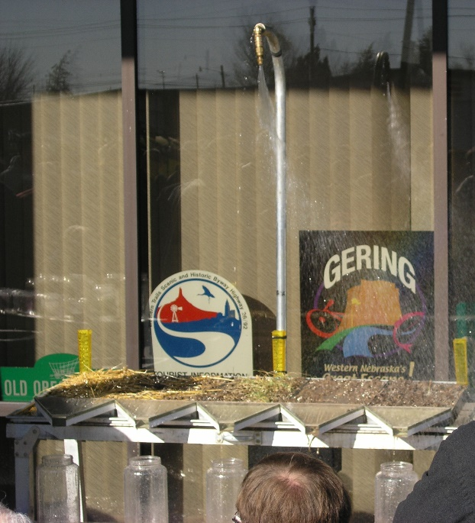
Materials:
Simulator equipment – sprinkler or watering can; soil boxes/pans; funnels; catch jars; angled frame or boards

Method:
- A rainfall simulator similar to the one shown in Fig. 1 may be built using an oscillating sprinkler suspended above an inclined frame with trays or boxes for soils, funnels for run-off, and jars on a table or bench to collect the run-off.
- Some of this equipment could be modified to build an inexpensive or small-scale simulator using a hand sprinkler or watering can (Fig. 2) and sprinkling each soil sample for a standard period of time and from a standardized height.
Figure 1. Demonstration of a rainfall simulator using soils with differing amounts of residue and tillage management. Photo by K.A. Nichols.
- (Optional) The boxes or trays may placed at different inclines to simulate different slopes using boards under one end of the box. Watering intensity may be varied by holding the can or sprinkler at a different height above the box or increasing the water pressure. Food coloring may be added to the catch jars to improve visibility. Crop residue, leaves, twigs, rocks, strips of sod or growing plants may be placed in the boxes to show the impact of soil cover on erosion. Rocks, popsicle sticks and wire mesh can be used to simulate a bulkhead.

Observations:
- Observe the amount of soil eroded (Fig.3), the amount of water in the jars, and the amount of scum in the jars under differing conditions – soil treatments, presence/amount of cover, rainfall height and intensity, and pan slope.
- Take the soil trays and invert them on a plastic mat. Observe how wet the soil is at the bottom of the pan (Fig. 3).
Figure 2. A watering can may be used to simulate the action of rainfall on soil in a metal tray or wooden box. Diagram from Hold That Soil website.

What is happening:
- The structure of the soil and amount of reduce impacts infiltration rates and water run-off. In a well structured soil with stable aggregates and lots of pore space, the water will infiltrate rapidly and the soil will be wet to the bottom of the pan. Residue can also help to physically prevent water erosion. Without stable aggregates and good pore space, the water will run-off the surface taking soil and nutrients with it and the soil on the bottom of the pan will be dry.
- Water movement on the soil surface and levels of erosion and run-off will be impacted by the slope and rainfall intensity and amount. This shows how much more important soil structure and cover are on different landscapes and in different regions.

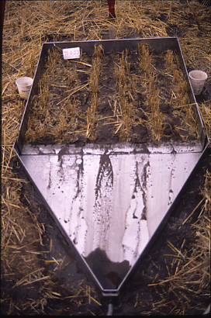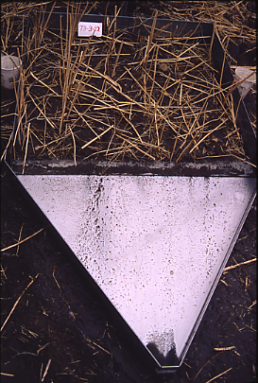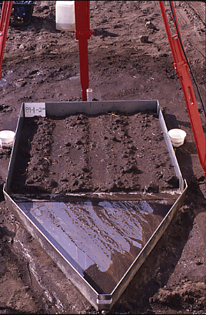
Conventional
Residue
No-till
Figure 3. The amount of topsoil runoff varies depending upon management. In a system that was conventionally managed but has 30% residue cover added had less loss than a conventional system without residue, but a no-till system with the residue left on the field had very little soil loss by erosive forces. Photos by K.A. Nichols.

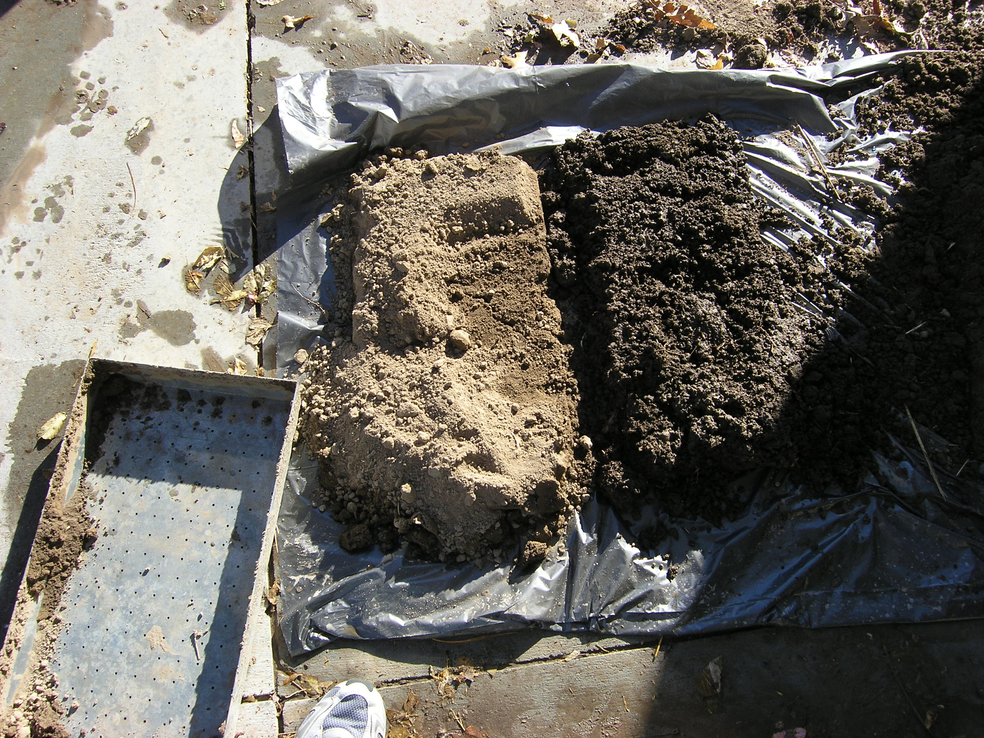
Conventional
No-till
Figure 3. The soil at the bottom of the pan from the conventionally managed system was dry due to low water infiltration while the soil in the no-till system was wet all the way to the bottom indicated good water infiltration. Photos by K.A. Nichols.

