Soil Texture

USDA-Natural Resources Conservation Service

Introduction:
The USDA classifies soils into twelve types which it calls soil textures. This classification is based on the relative percentages of sand, silt and clay. This can be visualized by the use of the USDA Soil Textures Triangle (see picture below). Soil texture may impact soil functions, including water and gas movement.

Materials:
Shovel
Mason jar or other leak-proof jar with a lid
Dish soap
Water
Ruler
Calculator

Method:
- Collect 2 shovels full of soil to a depth of 0-6 or 0-12 inches in a large bucket at the desired location. Remove all large rocks and loose vegetative matter-twigs, etc. Mix up the remainder thoroughly.
- Place 2-4 cups of this material into a jar.
- Add water to completely cover.
- Add non-foaming detergent (dishwasher soap).
- Shake vigorously until the material has gone into solution.
- Set jar aside and allow the material to settle into distinct layers, usually overnight.
- Place approx. ½ cup of crumbled soil sample (rock-free) in a labeled (on the lid) jar. Add 1 heaping tablespoon of the dishwasher powder. Add water to ‘neck’ of the jar (approx. 3 ½ cups). Cap and shake but alternately inverting the jar for five minutes. Allow the jar to sit on a level surface, undisturbed for 24 hours.

- At the end of the 24 hours, mark the depth of settled soil; this is the total depth (cm).

- Shake the jar again, as above, for five minutes. Let the jar sit, undisturbed, for 60 seconds. Mark the depth of the settled soil; this is the sand layer (cm).

- Continue to let the jar sit undisturbed for 30 minutes, after which, mark the depth of the settled soil; this is the silt layer (subtract the sand layer, cm).

- The remaining unsettled particles in suspension represent the clay layer. The depth of the clay layer can be calculated by subtracting the depths of the sand and silt layer (Steps 3 and 4) from the total depth (Step 2).

- To determine the soil type or textural class, use a ruler to measure the depth of each layer – starting with sand at the bottom and clay at the top. Divide each depth by the total height of all three classes of particles (i.e. sand, silt, and clay) and multiple by 100 to get the percentages. Enter the percentage of sand and silt into the table below and click on ‘Get Type’ at this website: http://www.nrcs.usda.gov/wps/portal/nrcs/detail/soils/survey/tools/?cid=nrcs142p2_054167

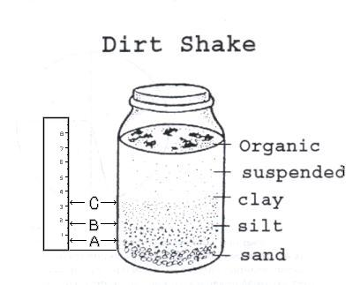
Figure 1
Sediment Measurement

USDA classification
Sand
Soil particles between 0.05 and 2.0 mm in size
Can be further divided into coarse, medium, and fine sand with a sieve test
Silt
Soil particles between 0.002 mm and 0.05 mm
Clay
Soil particles smaller than 0.002 mm (2 microns) in size

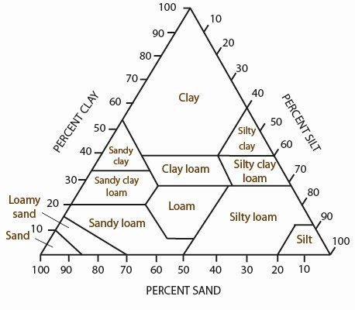
Clay Layer Height:
Silt Layer Height:

Sand Layer Height: _____________

Total Soil Height: _____________

Percent Sand [(Sand Height ÷ Total Height) x 100]: _________________________________
Percent Silt [(Silt Height ÷ Total Height) x 100]: _________________________________
Percent Clay [(Clay Height ÷ Total Height) x 100]: _________________________________

Soil Texture: _________________________________

