Infiltration Test

The infiltration test is generally performed after the first respiration measurement. The same 6- inch diameter ring left in place from the soil respiration test can be used for the infiltration test. If soil respiration was not determined, follow the instructions in Step 1 of the soil respiration proce- dure (Chapter 2) for inserting the 6-inch diameter ring.

Materials needed to measure infiltration:

6-inch diameter ring (left in soil from respiration test)
  - plastic wrap
Did You Know?
Infiltration rate is a measure of how fast water enters the soil. Water entering too slowly may lead to ponding on level fields or to erosion from surface runoff on sloping fields.
  - 500 mL plastic bottle or graduated cylinder
  - distilled water
  - stopwatch or timer

"Evaluation of Water Infiltration Rate (field activity)"

Goal
To demonstrate how water infiltration is influenced by management techniques.

Description
Water infiltration rate is tested with a ring of irrigation pipe, plastic wrap, and water. Great field activity for group presentations.

Materials
- sturdy metal, 6-15-cm diameter x 20-25-cm tall, open-ended cylinders (rings) such as irrigation pipe, stove pipe, coffee cans, well casing
- hammer or mallet
- wooden block or thick board that is big enough to cover the cylinders
- plastic food wrap or other flexible plastic material
- stopwatch or watch w/second hand for timing speed of water infiltration
- pencil and data sheet
- water
- container to measure out water

Method
- Calculate the volume of water needed to fill one of your rings to 5cm by using the following formula: (radius [in cm] of the cylinder)2 x 5 x 3.14 = amount needed in ml).

- Draw a line 5 cm up from one end on the outside of each of the infiltration rings. You will need this line as a reference when you are inserting the rings into the soil.

- Select a site in the field that is representative of the conditions that the plants will experience. Realize that in a field, there are areas that are compacted from wheel or human traffic and other areas that have not been compacted by these forces. You may wish to compare several areas within the same field, or compare fields with varying management histories. Compare in-row (between plants) to wheel-lanes, or no-till vs. tilled fields with same crops.

- Clear away any large surface debris and place the ring on the chosen spot.

- Place the protective wooden block on top of the ring, and tap it in with the mallet to the previously drawn 5-cm mark.

- Remove the block and line the ring with plastic food wrap.

- Carefully pour the pre-measured amount of water into the plastic-lined ring.

Considerations: If the soil is saturated, infiltration will not occur. Wait for one or two days to allow for some drying. Also, if the respiration test is not performed, make sure the sampling area is free of residue and weeds or that vegetation is trimmed to the soil surface before inserting the ring.

Firm Soil
1

With the 6-inch diameter ring in place, use your finger to gently firm the soil surface only around the inside edges of the ring to prevent extra seepage. Minimize disturbance to the rest of the soil surface inside the ring.

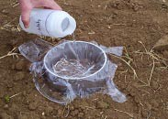Line Ring with Plastic Wrap
2

Line the soil surface inside the ring with a sheet of plastic wrap to completely cover the soil and ring as shown in Figure 3.1. This procedure prevents disturbance to the soil surface when adding water.

Add Water
3

  - Fill the plastic bottle or graduated cylinder to the 444 mL mark with distilled water.

  - Pour the 444 mL of water (1" of water) into the ring lined with plastic wrap as shown in Figure 3.1.
Figure 3.1


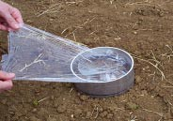Remove Wrap and Record Time
4

- Remove the plastic wrap by gently pulling it out, leaving the water in the ring (Figure 3.2). Note the time.

- Record the amount of time (in minutes) it takes for the 1" of water to infiltrate the soil. Stop timing when the surface is just glistening.

- If the soil surface is uneven inside the ring, count the time until half of the surface is ex- posed and just glistening (Figure 3.3).

- Enter the amount of time in minutes on the Soil Data worksheet.

Repeat Infiltration Test
5

Figure 3.2

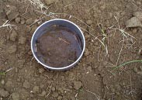
Figure 3.3

In the same ring, perform Steps 2, 3, & 4 with a second inch of water. On the Soil Data worksheet, enter the number of minutes elapsed for the second infiltration measurement. If soil moisture is at or near field capacity, the second test is not necessary.

[The moisture content of the soil will affect the rate of infiltration; therefore, two infiltration tests are usually performed (if soil is dry). The first inch of water wets the soil, and the second inch gives a better estimate of the infiltration rate of the soil.]

Replace Lid
6

If a second respiration measurement will be performed, set the lid loosely on the ring and leave it covered for preferably 16 to 24 hours (6-hour minimum) before beginning the second test (Chapter 2). (Remove lid and replace it before beginning the second soil respi- ration measurement).


Reminder: If you still need to perform the second
respiration measurement, remember to loosely
!

Water Infiltration, Water Holding Capacity, and Nitrate Leaching

Nichols and Samson-Liebig, 2011

Introduction:

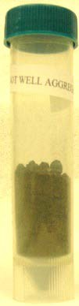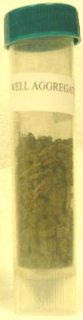Soil structure – the size, amount, and continuity of pores with the soil matrix – is the leading factor in soil functions – water and air movement and nutrient cycling. This demonstration will be used to show how structure and function interact.
A
B
Figure 1. Air dried soil samples of the same weight (25 g) from conventional (A) and no-till (B) soils. Volume differences demonstrate the
role that aggregation has in

Materials:

Disposable paper or plastic cups – two sizes Needle or small nail
Soil samples Water
Graduated cylinder or measuring cup, optional

Method:

- Prepare 5 oz paper cups* (1 per sample) as follows:

  - Using an 18G needle (quilting needle) or small nail (such as a finishing or picture nail), poke 25-50 holes in the bottom of the paper cup.

  - 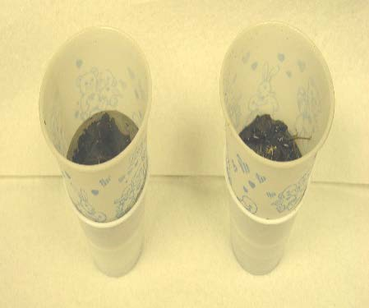Draw a line on the outside of the cup where the circumference equals 15.5 cm (about 3 cm from the bottom)
A
B
  - Place the 5 oz paper cup in a 3 oz paper or plastic cup.
- If conducting the experiment in the field, use a trowel to dig a hole 10 cm deep and about 5 cm wide. If conducting the experiment in the laboratory or classroom, use field moist or air dried soil that has been pre-measured to either the same volume or weight (Fig. 1).**
Figure 2. Water pools on the surface and does not infiltrate in the not well aggregated sample (A) but does infiltrate
rapidly in the well aggregated
- Transfer enough soil into the 5 oz paper cup to reach the line drawn on the cup. Shake the cup gently to evenly distribute the soil and gently break-up any large clods.
- Add 50 ml water.*** (This is equal to about 2.54 cm or 1 in.)
- Start timing infiltration (Fig. 2). Stop and record when complete (i.e. when the surface of the soil is just glistening).****
- Collect and examine water height in 3 oz. cup, and transfer to tubes (i.e. container with a lid) after infiltration complete.
- Optional tests:

  - Measure volume of water collected using a graduated cylinder in field or lab (Fig. 3).

  - Test water for soil nitrates using nitrate test strips.

  - Measure cations and anions in water using an ion chromatograph.

  - Estimate water holding capacity by: i. weighing wet soil in the cup after completing the infiltration experiment, ii. incubating the sample at room temperature and weighing the soil in the cup daily until the weight no longer changes, and iii. calculating the percent water in the sample for each day and graph percent water by time to examine the water holding capacity of each sample.

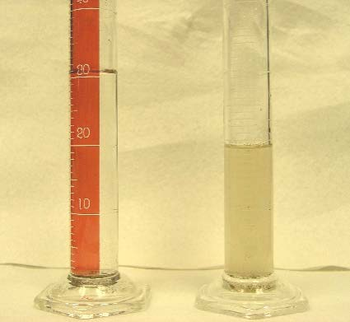* Other containers besides the paper cups may be used. You will need one container that you can poke holes into and another container that you can fit the top container into to collect the water. The volume of water and amount of soil may have to be adjusted as described below.
A
30
B
30
20
20
10
10
Figure 3. In the not well aggregated soil (A) 31 mls of water was collected in the bottom cup whereas the well aggregated soil (B)
had 19 mls of water (blue
** These same procedures can be used in the field, laboratory, or classroom on field moist or air-dried samples. Air-dried samples can either be measured to the same volume or weight. If weight is used, a well aggregated soil will typically have a greater volume of soil. This may be useful to demonstrate porosity. In some cases when using air-dried samples, filling tall
and narrow containers to high, or in highly organic soils, may require adding a second 50 ml to have a measurable volume of water in the bottom cup.
*** Ultrapure water is preferred, but distilled or tap water may be used. However, if ions, such as nitrate, are measured, a no soil control should be used for background correction.
**** In some cases, large amounts of roots or plant material in rangeland soils may result in low infiltration rates. However, the amount of water held by these soils will be higher than in cropland soils.

Calculations for Adjusting Water and Soil Volumes by Container

The volume (V) of water added needs to be adjusted based on the diameter (D) of the containers used in order to add a cylinder of water that is 2.54 cm high on top of the soil. The diameter may be estimated by measuring the circumference (C) of the container at the height
- of the soil (Fig. 4, Eq. 1). The diameter value is then used to calculate the volume of water (Eq. 2).

Note: The height of the soil may vary depending on the diameter of container. The volume of water does not take into account the height of the soil and filling narrow containers more than 4 or 5 cm may require another 2.54 cm to collect a measurable volume of water.

C = π * D (1)

V = π * (D/2)2*h (2)

Observations:
Figure 4. A 5 oz. cup with a perforated bottom is placed in a 3 oz. cup.
The soil is placed in the 5 oz. cup to a height of 3 to 5 cm depending on the diameter (D) of the cup and a volume of water equivalent to a height of
5 oz. cup
2.54 cm H₂O Soil
3 oz. cup

  - Compare the water infiltration times for the different soil samples.
  - Estimate the water holding capacity by measuring the amount of water in the bottom cup and subtracting from the amount added. You could also measure the soil weight before and after the addition of water.
  - Compare the estimate nitrate concentrations in the water using the nitrate test strips.

What is happening:

- In a well-aggregated soil, such as soil from an organic and/or no-till system, the spatial distribution of the aggregates gives pore space between the aggregates which allows for rapid water infiltration. If the aggregates are ruptured by the influx of water, the pores are filled with the fine soil particle released from the aggregates.
- The pore space also provides a location for water to be held. In addition, well- aggregated soils, typically, have higher organic matter levels in and around the aggregates. This organic matter can act like a sponge and hold water.
- The amount of nitrate in the water may show which systems have the potential for nitrate loss by erosion and leaching.

"Water Holding Capacity & Bulk Density of Compost vs. Soil"

Goal
- To demonstrate the differences in bulk density and water holding capacity between compost (humus proxy) and the mineral soil components.

Description
Two graduated cylinders containing equal weights of soil and compost, with the addition of equal amounts of water, are used to show differences in water-holding capacity of humus vs. degraded soil. Good demo to do in front of the audience.

Materials
- two 1000-ml glass or plastic graduated cylinders, or any other tall clear containers of the same size. Tall, narrow containers produce the most dramatic result.
- poor, clayey, air-dried subsoil with large clods broken up (about 2 L)
- fine-textured, mature, air-dried compost (about 2 L)
- water
- beaker or measuring cup to measure out known quantities of water
- two identical containers to hold the water used during the demonstration (about 1L capacity)
- labeling tape and indelible marker
- scale to weigh out soil andcompost
Method Test run
- Place one of the graduated cylinders on the scale and tare it. Fill the cylinder
with dry compost to about the 900-ml line. Record the weight.

- Measure out a known quantity of water and add it, a little at a time, to the cylinder of compost. You might need to add as much as 500 ml of water to 500 g of dry compost. Keep adding water, a little at a time, until the compost is saturated but not flooded. Allow time between additions for the water to soak into the compost. Record the amount needed to saturate the compost.

Live demonstration
- Label two cylinders appropriately.

- Add the amount of dry compost determined during the test run to the appropriately labeled cylinder.

- Weigh out the same amount of soil in the other cylinder. The soil should have

about½ the volume of thecompost.

- Measure out two containers of water with the amount you determined during the test run.

"Evaluation of Water Infiltration Rate (field activity)"

Goal
To demonstrate how water infiltration is influenced by management techniques.

Description
Water infiltration rate is tested with a ring of irrigation pipe, plastic wrap, and water. Great field activity for group presentations.

Materials
- sturdy metal, 6-15-cm diameter x 20-25-cm tall, open-ended cylinders (rings) such as irrigation pipe, stove pipe, coffee cans, well casing
- hammer or mallet
- wooden block or thick board that is big enough to cover the cylinders
- plastic food wrap or other flexible plastic material
- stopwatch or watch w/second hand for timing speed of water infiltration
- pencil and data sheet
- water
- container to measure out water

Method
- Calculate the volume of water needed to fill one of your rings to 5cm by using the following formula: (radius [in cm] of the cylinder)2 x 5 x 3.14 = amount needed in ml).

- Draw a line 5 cm up from one end on the outside of each of the infiltration rings. You will need this line as a reference when you are inserting the rings into the soil.

- Select a site in the field that is representative of the conditions that the plants will experience. Realize that in a field, there are areas that are compacted from wheel or human traffic and other areas that have not been compacted by these forces. You may wish to compare several areas within the same field, or compare fields with varying management histories. Compare in-row (between plants) to wheel-lanes, or no-till vs. tilled fields with same crops.

- Clear away any large surface debris and place the ring on the chosen spot.

- Place the protective wooden block on top of the ring, and tap it in with the mallet to the previously drawn 5-cm mark.

- Remove the block and line the ring with plastic food wrap.

- Carefully pour the pre-measured amount of water into the plastic-lined ring.

"Aggregate Stability using Coffee Filters"

Goals
- To illustrate differences in soil aggregate stability using soils from different management regimes.
- To show how organic matter improves aggregate stability.
- To demonstrate erosion potential of soils with varying amounts of organic matter.

Description
Water is poured through coffee filters containing dry soil aggregates. Topsoil and subsoil can be compared for dramatic differences in color, organic matter and aggregate stability.

Materials:
- clods of air-dried high organic matter topsoil and degraded soil or subsoil
- two cone-shaped (Melita type) coffee filter baskets or laboratory funnels
- paper coffee filters to fit baskets or funnels
- two clear containers to collect soil filtrate (any clear container large enough to hold the coffee filter baskets securely so they won't topple over while conducting the experiment - use matching containers if possible)
- white paper (optional)
- water
- two same-sized beakers or measuring cups to measure out water (they should hold at least as much as the filtrate collection containers)

Method:
- Label the filtrate collection containers and filter baskets with the soil types you are comparing.

- Put the paper coffee filters in the baskets, and place the baskets on top of the matching container.

- Place the containers on white paper (or other light-colored surface) to better show the differences in the color of the leachate coming from the two soils.

- Gently break up the soil clods into small chunks.

- Fill the filter baskets ¾ full with soil.

- Measure out equal amounts of water in the measuring cups. Use a little less than the total volume of the filtrate collection container.

Slowly pour the water over the soil in the filters. A member of the audience can do this part

