Scum Test

Wright and Upadhyaya, 1998; 1999

Materials:
Shovel Bucket Water
Plastic mesh bag or sieve

Method:
- Collect soil samples from two or more sites with a shovel keeping it intact as much as possible.
- Air-dry the sample, if possible, trying to keep it intact.
- Drop the sample into a large bucket filled with water. Alternatively, you could place the sample in a large mesh screen or fine net and gather the edges to form a bag.
- Manually move the sample up and down in the water to break it apart as much as possible using the bag or net or holding onto a small portion of the sample, such as part of the stem from the soil surface.

Observations:
- Observe bubbles, white or brownish scum on water surface, and how quickly and how much of the sample breaks apart (Fig. 1).
- Compare how much of the sample remains in the bag or net as stabilized aggregates or, if a bag was not used, place hands in bucket and feel the texture of the soil. Does it have well-aggregated pellets?

What is happening:
- Initially, bubbles, scum, and fine debris will be released as the air in the pore spaces between aggregates within the soil sample is replaced by water.
- As you manually move the sample up and down in the water, more bubbles, scum and fine debris will form on the water surface. Amounts of bubbles and scum will vary depending upon the stability of the aggregates (as mentioned above) within the sample.
- As the aggregates are ruptured, the soil will be washed out of the bag or net, if used, and fine soil particles to collect on the bottom. Stabilized aggregates will remain in the bag or net, if used. If a bag or net is not used, the soil on the bottom of the bucket will have a fine, smooth texture if it is not very stable, but if it is stable, it will feel like it contains small beads or tapioca.
- The scum is an indicator of the presence of glomalin in the soil, but this glomalin is not attached to aggregates. In some cases the scum will appear more brownish than white due to the fine particles within the soil which float to the surface as well or due to iron binding to glomalin in the soil.

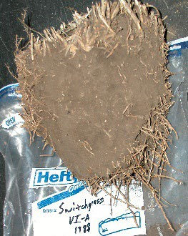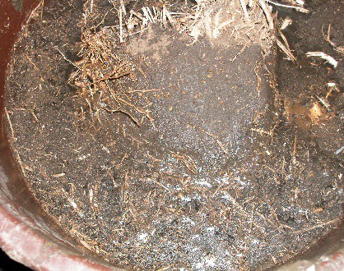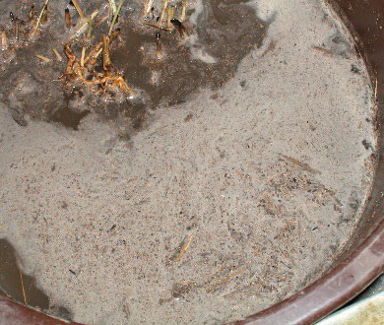

Switchgrass Switchgrass – Immediately After Placing in Water
Switchgrass – After
Submerging and Disruption

Figure 1. A soil sample collected with a shovel under switchgrass plants was placed in a bucket of water and then manually moved up and down to test the stability of the sample and look at the production of scum on the water surface. Photos by K.A. Nichols.

