Healthy Soil Pie Demonstration

Introduction
In these exercises, cake pans are used to create literal pie charts to illustrate the composition of soil below our feet. Below ground, soil contains open space (i.e. pore space) filled with air and water and solid space filled with soil minerals and organic matter. Healthy soil contains even amounts of pore and solid space with the pore space split evenly between air-filled and water-filled (Figure 1). As soil dries, the amount of water-filled pore space decreases and air-filled space increases. When compaction increases, the amount of pore space decreases and solid space increases (i.e. soil minerals). Compacted soils may become more easily saturated and anaerobic (i.e. without oxygen), because the amount of pore space is small and fills with water following precipitation. Anaerobic conditions also may occur in compacted soils without precipitation because the pore space is small with few openings at the soil surface and little gas exchange (i.e. oxygen in and carbon dioxide out). In a soil with more pore space, there are more and larger openings at the soil surface which allows oxygen to enter the soil and carbon dioxide produced from soil biological respiration from macroscopic and microscopic organisms and plant roots to flow out of the soil.
Soil texture is defined by the amounts of sand, clay and silt in the solid portion of soil. There is pore space between soil minerals (i.e. sand, clay and silt) with sizes of these minerals and how they fit together impacting the total amount and sizes of this pore space. The crystal shape of sand grains prevents them from fitting tightly next to each other which means sandy textured soil typically has a lot of pore space. If the sand is mostly fine sand, the pore spaces are smaller while coarse sand soils have large pores. The size of the pore space impacts water movement with water moving easily in and out of large pores and pores holding more water. Small pores hold less water and it is harder for water to move into and out of the pore space because small connections between pores slow the rate of water movement. In addition to impacting the size of and connections between pores, the structure and atoms used to form soil minerals – sand, clay, and silt – influences their functions. Sand are made mostly of metal atoms such as iron, silica, calcium, and aluminum in a crystal structure which limits their function. Clay minerals are also made of metal atoms – mostly silica – but in a layered structure which increases their functions particularly their water retention capability and cation exchange capacity (CEC). Nutrient availability to plants is higher in clay soils because of their CEC, but clay soils are more compacted due to their small size and ability to fit tightly together. Higher compaction along with more water retention between the clay layers mean clay soils may become saturated and anaerobic for periods of time. The water retained between the clay layers is mostly unavailable to plants.
Organic matter impacts porosity (i.e. the amount of pore space) and soil function based on what types of carbon compounds its made from and the amount of decomposition of these carbon compounds. The majority of soil functions, typically >95%, come from organic matter with more decomposed organic matter having lower functions. Critical soil functions are water and nutrient movement, retention and availability; gas exchange; and microbial activity.
The white paper in these demonstrations indicates air-filled pore space while the blue paper or water picture is for water-filled pore space. Mineral soil (i.e. solids) is represented by crushed, degraded soil or subsoil (i.e. B horizon soil) while the organic matter portion of the solids is illustrated by mostly decomposed plant residues, duff layers, or compost. To demonstrate the differences between textural minerals – sand, clay, and silt – of soil, these minerals may be separated from each other by sieving the degraded soil or subsoil. Sand (i.e. play sand) and clay minerals may also be purchased to better illustrate the impacts of their sizes and shapes on soil porosity and compaction.
In this demonstration, the sizes of the sections (i.e. percentages) may be adjusted to illustrate differences in porosity and compaction (i.e. space filled with solids) by moving the heavy index cards separating the soil air (i.e. white section), water (i.e. blue section), and soil particle (i.e. crushed degraded soil or subsoil) spaces. Soil textural information from the Soil Texture test may be used to adjust the sections to match your soil according to the amounts of each soil particle – sand, silt, and clay – to put in the pan.

Materials
8–9-inch round, straight-sided, metal cake pan
4–6-inch round, straight-sided, metal cake pan
Crushed dry degraded soil or subsoil (soil low in organic matter) – mineral soil
Decomposed plant material, duff, and/or compost – organic matter
Heavy index cards or cardstock – separators
Heavy white paper or cardstock – air-filled pore space
Heavy blue paper, cardstock or a picture of water from a magazine – water-filled pore space
Clear tape
Glue or paste
Coarse and fine sand (play sand or 0.05-2 mm particles sieved from degraded soil or subsoil)
Silt particles (0.002-0.05 mm particles sieved from degraded soil or subsoil
Clay minerals (clay mineral may be purchased or <0.002 mm particles sieved from degraded soil or subsoil)
Scale or balance
Spatula or stir stick
Camera or camera on mobile device, optional

Method
The 8–9-inch cake pan will be used to illustrate the composition of soil below your feet while the 4–6-inch cake pan will illustrate soil texture or the concentrations of different soil particles – sand, silt particles, and clay minerals – and organic matter.
Volume of Healthy Soil
- Cut two pieces of both white and blue paper to fit in the bottom of the 8–9-inch cake pan. Set one of each – white and blue – aside for now.
- Fold the other one of each pieces of paper – white and blue – into quarters and cut in quarters. Set three of the quarters aside with the full-size pieces from step 1.
- Take remaining one of the quarter of both – white and blue – pieces of paper, fold in half, and cut. Set one half aside.
- Take the other one-eighth pieces, fold in half and cut. Set one half aside.
- Take one of the one-sixteenth pieces, fold in half, and cut. There will be eight pieces of paper for each color – white and blue: one full-sized circle, three quarter-sized, one eighth-sized, one sixteenth-sized, and two pieces one thirty second in size. gives three pieces which are one-quarter in size, one piece one-eighth, one piece one-sixteenth, and two pieces equal to one-thirty second in size. Set these pieces aside except for the full-sized white piece.
- Glue this cake pan size of white paper from step 1 to the bottom of the pan.
- Glue one of the quarters of blue paper from step 2 on top of the white paper on the pan bottom. The bottom of the pan now will be three-quarters white and one-quarter blue.
- Cut the index cards to have four smaller index cards. Each smaller index card should be long enough to reach halfway across the cake pan (i.e. equal to the cake pan radius) and high enough to reach about a ½ inch or 2 cm above the top lip of the pan.
- Tape index cards into the pan to separate the blue paper section (i.e. water) from the white paper sections and one quarter of the white paper (i.e. air) is on one side with all the white paper on the other side (Figure 1).
- Tape an index card to divide the 50% white paper section on one side into a portion which is about 10% of the whole cake pan (Figure 1),
- Weigh the cake pan with the white paper on the bottom and the index cards and tare the scale or record the weight.
- Add mineral soil to the 40% section using a spatula or stir stick to spread the mineral soil into a thin layer to fill the space.
- Weigh the cake pan with the mineral soil and record the weight of the mineral soil. Determine the weight of the mineral soil by weighing on the tarred scale or by subtracting the weight of the cake pan from step 11 from the weight of the cake pan with mineral soil.
- While on the scale, add organic matter to the 10% section in the cake pan at an amount equal to 10% of the weight of the mineral soil. For example, if the mineral soil weighs 2 ounces or 50 grams, then the organic matter should weigh 0.2 ounces or 5 grams (Figure 1),
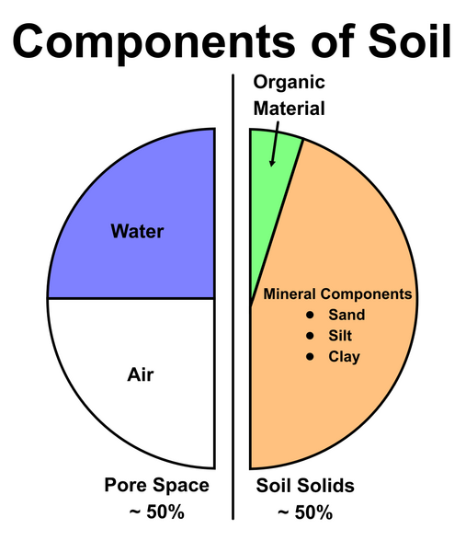
- Use a spatula or stir stick to spread the organic matter into a layer to fill the space.
Figure 1. Components in a volume of healthy soil.
https://serc.carleton.edu/mathyouneed/geomajors/ternary/index.htm
- Observe the amounts of air-filled (white) pore spaces between the mineral soil and organic matter particles (Figure 1).
- Optional: Take a picture and use image analysis software like ImageJ to calculate the amounts of air- (white) and/or water- (blue) filled pore spaces including under the mineral soil and organic matter.

This illustrates how a healthy soil should look: 50% open space and 50% filled with solids, half of the open space will be filled with water and half with air (i.e. 25% blue paper section and 25% white paper section), and the solid filled space will be mostly filled with low organic matter, degraded soil and a smaller portion with organic matter (i.e. about 10% of the pan with organic matter and 40% with degraded soil) (Figure 1).

Modifications to illustrate changes in porosity and compaction
- Tape pieces of white paper from steps 2-5 over the blue paper section and move the index card to show what happens as the soil dries out [i.e. blue (water) section decreases while white (air) section increases].
- Move the index cards around and add or remove mineral soil and/or organic matter to illustrate how porosity (i.e. open space filled with water or air) decreases and compaction increases (i.e. solid-filled space). Use the scale to maintain accurate amounts of mineral soil and organic matter according to their percentages. Do not expand the crushed soil or organic matter into the water-filled spaces.
- Simulate rainfall by placing the blue cake pan size piece of paper from step 1 over the white paper on the bottom of the cake pan to show saturation. Put pieces of white paper from steps 2-5 over the blue paper in the open space section and under the mineral soil or organic matter to illustrate drying. Eventually remove the whole piece of blue paper from on top of the white paper and use pieces of blue and white paper from steps 2-5 and moving the index cards to further illustrate drying. The open space section will dry more quickly followed by the mineral soil section and by the organic matter section. Note that the drying pattern is not sequential but rather uneven meaning mineral soil will dry at about a third of the rate of open pore space sections and organic matter at about a third of the rate of mineral soil.
- Optional: Take pictures after any of the adjustments above and use image analysis software like ImageJ to calculate the amounts of air- (white) and/or water- (blue) filled pore space.

Observations/What’s Happening
- Observe and compare the amounts of white space between the individual particles of organic matter and mineral soil. This illustrates the increase in porosity with organic matter versus mineral soil.
- Observe what happens as the soil dries out and white space increases. Larger open spaces (i.e. bigger pores) will dry out more quickly. However, even with larger pores organic matter will retain water better than mineral soil. Higher clay contents in mineral soil also will retain water better than more sandy soils. The modifications in this demonstration should illustrate these differences. Adding the pieces of white and blue paper and moving the index cards to adjust the amounts of air- and water-filled spaces in the open areas and under mineral soil and organic matter particles.
- Observe what happens to the amount of white and blue space as the amounts of mineral soil and organic matter increase and/or decrease. This illustrates how the amounts of mineral soil and organic matter impact saturation.
- As solids (i.e. mineral soil and/or organic matter) increase in the soil and compaction increases, soils are more easily saturated, and soil becomes more anaerobic (i.e. lower in oxygen).

Method, continued
Soil Texture or Mineral Soil Composition
- Cut pieces two pieces of both white and blue paper to fit in the bottom of a 4–6-inch cake pan.
- Glue one of the white pieces to the bottom of the cake pan. Set one of the blue pieces aside for later.
- Fold one of each of the other pieces of paper – white and blue – into quarters and cut in quarters. Set three of the quarters aside with the full-size piece of blue paper from step 1.
- Take remaining one of the quarter of both – white and blue – pieces of paper, fold in half, and cut. Set one half aside.
- Take the other one-eighth pieces, fold in half and cut. Set one half aside.
- Take one of the one-sixteenth pieces, fold in half, and cut. Along with the remaining full-sized piece of bule paper, there will be seven pieces of paper for each color – white and blue: three quarter-sized, one eighth-sized, one sixteenth-sized, and two pieces one thirty second in size. gives three pieces which are one-quarter in size, one piece one-eighth, one piece one-
- Cut five index cards to divide the pan into sections with each piece being about 2–3 inches long (i.e. long enough to meet in the middle) and high enough to reach about ½ inch or 2 cm above the top lip of the pan.
- Position two of the index card pieces to create an area which is about 10% of the whole pie and tape the pieces down.
- Divide the remaining space into thirds with the additional index cards and tape them down.
- Weigh the cake pan with the white paper on the bottom and index cards dividing it into four sections. Tare the scale or record the weight.
- Place sand into one of the sections created in step 9 and use the spatula or stir stick to spread the sand into a thin layer to fill the space.
- Weigh the cake pan with the sand and record the weight of the sand. Determine the weight of the sand by weighing on the tarred scale or by subtracting the weight of the cake pan from step 10 from the weight of the cake pan with sand.
- Tare the scale or record the weight of the sand and add silt to one of the other thirds at a weight equal to the sand.
- Tare the scale or record the weight of the cake pan plus paper, index cards, sand, and silt. Add clay to the final large section.
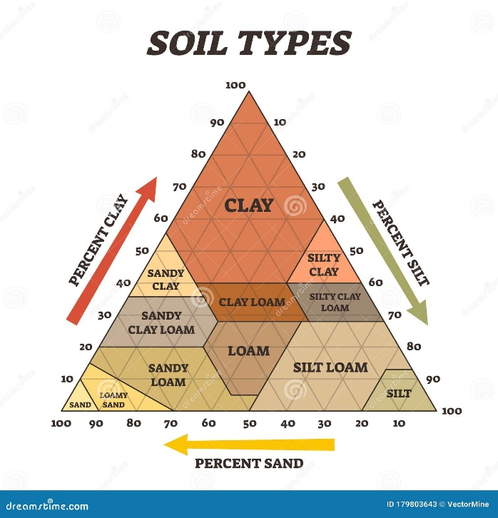
- Tare the scale or record the weight of the cake pan plus paper, index cards, sand, silt, and clay. Add organic matter to the 10% section in the cake pan at an amount equal to 10% of the weight of the sand. For example, if the sand weighs 1 ounces or 25 grams, then the organic matter should weigh 0.1 ounces or 2.5 grams
- Remove from the scale, use the spatula or stir stick to spread the silt, clay, and organic matter into a thin layer to fill the space.
- Observe the amounts of air-filled (white) pore spaces between the particles in all the sections.
- Optional: Take a pictures and use image analysis software like ImageJ to calculate the amounts of air-filled (white) filled pore spaces.

The ideal soil texture is a loam which has even proportions of sand, silt, and clay.
Figure 2. The Soil Texture Triangle provides the texture label based on percentages of sand, clay and silt.

Modifications to illustrate changes in porosity and compaction
- Move the index cards around and adjust the amounts of sand, clay, silt, and organic matter using the scale to match your soil texture or regional soils.
- Simulate rainfall and drying by replacing the white paper on the bottom of the cake pan with blue paper and using the pieces of blue and white paper from steps 3-6 under each of the minerals – sand, silt and clay – and organic matter. Eventually remove the whole piece of blue paper from on top of the white paper and use pieces of blue and white paper from steps 3-6. Water is held in the soil reducing the drying rate accordingly from organic matter to clay minerals to silt particles to sand grains. Therefore the drying pattern is not sequential but rather uneven and using the pieces of white and blue paper beneath each section differently will illustrate this drying pattern.
- Optional: Take pictures after any of the adjustments above and use image analysis software like ImageJ to calculate the amounts of both air-filled and water-filled pore space.

Observations/What’s Happening
- Observe the amount of white or blue space between the individual particles of sand, silt, clay and organic matter. More white space indicates more porosity and less compaction. As compaction increases with larger percentages of small particles such as clay minerals and fine sand and silt, there is less air (i.e. oxygen) in the soil increasing anaerobic (i.e. oxygen free conditions).
- Observe how the sizes and shapes of individual particles – sand grains, silt particles, clay minerals, and organic matter – impact the pore (white) sizes and shapes. The openings linking the pores together (i.e. pore continuity) influence how quickly or slowly water and air move through the pore space.
- Larger open spaces (i.e. bigger pores) will dry out more quickly. However, even with larger pores organic matter will retain water better than any minerals – sand, silt, or clay. Higher clay contents in mineral soil also will retain water better than more sandy soils. The modifications in this demonstration should illustrate these differences. Adding the pieces of white and blue paper and moving the index cards to adjust the amounts of minerals – sand, silt and clay – and organic matter.

Tips and Tricks
- Cake pans are recommended but their size may vary (i.e. keeping things smaller) or other types of pans or dishes may be used as long as they are circular and straight sided.
- Vary the percentages of air and water to illustrate the differences in porosity and compaction.
- Vary the mineral, air, and water portions to illustrate different horizons.
- Vary the different concentrations of soil particles – sand, silt, and clay – as well as organic matter to illustrate porosity and compaction for different soil types.

References
- https://ucanr.edu/sites/default/files/2022-08/371270.pdf
- Weil, R.R. 2017. The nature and properties of soils 15th ed. Prentice-Hall Inc. Upper Saddle River, New Jersey.

