SOIL YOUR UNDIES

Introduction
A quick and dirty way to test soil health and microbial activity on cropland, pastures, rangeland or forests is to bury 100% cotton underwear or cotton cloths or strips. Soil microbes are capable of decomposing cotton or natural fibers, and comparisons of the weights before and after burying are an indication of microbial activity/decomposition. Microbes are most active at or near the surface making burying at the 3-inch (5-cm) depth a good depth to use. The more the undies deteriorate (i.e. holes and partial openings), the healthier your soil/higher levels of microbial activity (Figure 1).

Materials
- 100% cotton underwear or cotton cloth (use full-sized underwear or cut underwear or cloth into smaller pieces)
- Scale or balance
- Data sheet
- Nylon bag or nylons/pantyhose (i.e. nylon)
- Flag or flagging tape
- Shovel/garden trowel
- Mobile device with camera and location services or camera and GPS system

Method
- Take a picture of the underwear or pieces of underwear or cotton cloth (i.e. cotton material). Optional - Calculate the size of the cotton material by measuring length and width of the cotton material and multiplying the values together.
- Place the cotton material in the nylon. If the nylon is open to the soil at the top or bottom, tie or seal the openings closed. If the nyon is stretched above the soil surface as described in Step 7, the top does not need to be tied or sealed.
- Weigh the cotton material in the nylon and record the weight.
- Dig a hole with a shovel 3-6 inches (5-15 cm). Make the hole wide enough to line the bottom with the cotton material in the nylon. Record the hole depth and any soil observations.
- Place the nylon with the cotton material in the hole. Lining the materials on the bottom of the hole to keep it at the same depth.
- Take a picture with a camera or mobile device and mark the GPS location using location services or a GPS system.
- Extend the nylon to the soil surface. (If a nylon bag is used it may not be possible to have part of it above the soil surface and the spot needs to be well marked.)
- Fill the hole with the soil removed while digging the hole while trying to maintain the soil structure and keeping part of the nylon on the soil surface.
- Mark the spot with a flag or flagging tape which may be tied to the nylon to make it easier to unbury and extract.
- After at least 35 days, carefully dig up the cotton material. (Note: 35 days during active plant growth is the minimum but the burial time may be extended to several months or up to a year depending on active plant growth and the size of cotton material buried. Full-sized underwear or large pieces of cloth may be buried for longer periods of time.)
- Take pictures of the nylon with the cotton material in it and note any soil and roots attached to the outside and growing into the nylon.
- Gently remove the soil, roots and debris attached to the outside of the nylon and the cotton material from inside the nylon. Turn the nylon inside out and remove any other debris inside before turning it back outside out.
- Take pictures of the cotton material removed from the nylon and make any necessary notes (Figure 1). Optional: Measure length and width of cotton material and multiple together to determine the size of the cotton material.
- Put the cotton material back in the nylon, weigh and record the weight.
- Rinse the nylon with cotton material by hand without soap to remove soil, roots, etc. inside and outside the nylon as well as attached to the cotton material.
- Air-dry for several days to a week or more to completely dry the cotton material.
- Weigh the nylon with the cotton material, record the weight, and compare to the weight prior to burying (step 3). If the weight is higher than in step 3, dry longer or wash again by hand without soap and repeat steps 16-17.
- Gently remove the cotton material from the nylon and take pictures (Figure 1). Optional: Measure length and width of cotton material and multiple together to determine the size of the cotton material.
- Optional – If the size of the cotton material was determined by measuring and multiplying the length and width in Step 1, then measure and multiple the length and width again.
- Optional – Use image analysis with a program like Image J to measure the size of the cotton material before and after burying (Steps 1, 13 and 18.)
- Use the differences in weight from Steps 3 and 17 or 14 to calculate the percentage of cotton material lost according to the equation below – higher values indicate more decomposition and microbial activity.

$$percentage of cotton material decomposed=\left[\left\{weight of cotton material in nylon before burying \left(Step 3\right)-weight of cotton material in nylon after unburying, rinsing and drying \left(Step 17 or 14\right)\right\}÷weight of cotton material in nylon before burying \left(Step 3\right)\right]×100$$

- Optional - Use the differences in size of cotton material from Steps 1 and 13, 18, or 19 to calculate the percentage of cotton material lost according to the equation below – higher values indicate more decomposition and microbial activity.

$$percentage of cotton material decomposed=\left[\left\{size of cotton material calculated before burying \left(Step 1 or 19\right)-size of cotton material calculated after unburying\left(Steps 13. 18, or 19\right)\right\}÷size of cotton material before burying \left(Step 1 ot 19\right)\right]×100$$

Modifications
- Bury cotton material in nylon at different depths to measure the differences in microbial activity at the surface compared to deeper in the soil. This may be done by putting several cotton materials in one long nylon and tying the nylon above and below the individual cotton material sample at a particular depth which allows them to be connected together in one nylon with only one hole being dug.
- Bury multiple cotton material in nylon ‘bags’ in the same field and unbury at different times every 30 to 60 days during the year.
- Bury different types of cloth (i.e. different weaves or types – such as muslin, wool, hides, leather) or natural materials such as leaves, bark, wood chips, roots, etc. Anything may be used as long as the material is 100% natural and hasn’t been treated, washed, or exposed to synthetic chemicals. (See It’s a Tea Party for additional details.)
- This test may also be conducted in pots with smaller pieces of cotton material. Care needs to be taken when burying and unburying the cotton material in nylon in pots to not destroy or kill the plants in the pot. The best way to do this in a pot would be to bury the cotton material in nylon when planting in the pot and unbury when harvesting or transplanting into a larger pot. Otherwise using large pots with enough room to bury and unbury the cotton material in nylon.

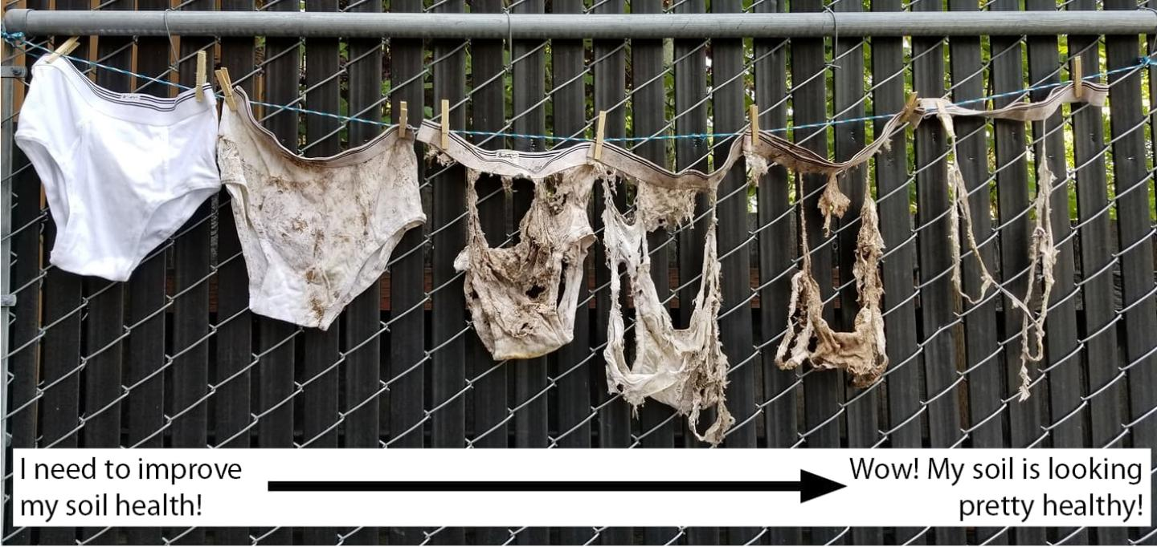
Figure 1. United States Department of Agriculture (USDA) - Natural Resources Conservation Service (NRCS) Soil Your Undies Challenge results indicate soil health based on the microbial decomposition (i.e. holes and tears) of underwear buried in soil.

Observations/What’s Happening

Observe what the soil looks like in the hole:

Observe the number and size of holes, partial openings, and tears in the cotton material.

Any 100% natural materials may be decomposed by soil microbes particularly bacteria and fungi leaving holes or partial openings in the cotton material (Figure 1).

More microbial activity and cloth decomposition will occur when plants are actively growing.

Fungi decompose materials at a slower rate and will decompose more woody material while bacteria act quickly. Most of the decomposition of cotton cloth will be performed by bacteria.

Tips and Tricks
- 100% cotton material need to be used because synthetic fibers will not decompose at the same rate as natural materials and this activity is attempting to simulate residue decomposition. As noted in the Modifications section, you can examine the decomposition of different materials, crop residues, plant leaves, stems, muslin cloth, hides, wood chips, leather, or teas (i.e. loose leaf or bagged green or black teas) may be used.
- Rolling up the materials and inserting them in the nylon bags or nylons/pantyhose may slow the decomposition – make sure the materials – cloths, leaves, wood chips, etc. have maximum contact with the nylon.
- Underwear or cloth without tight weaves (i.e. breathable or porous) and leaves will decompose more quickly primarily by bacteria while tighter weaves, muslin, wool, hides, leather, wood chips, or more woody materials will decompose more slowly. Slower decomposition is performed more by fungi. By using different types of 100%, untreated natural fibers, it indicates differing amounts of bacterial and fungi.
- The time of year or growing season will impact microbial activity and decomposition rates with more activity during active plant growth.
- It may be difficult to dig up the decomposed cotton cloth without it falling apart and loosing material. Putting the cloth in a nylon bag or pantyhose will help retain the undecomposed pieces while not decomposing itself. (Nylon will decompose and break apart but it will take years).
- Use both a flag/flagging tape and GPS to mark where you buried the cloths and/or extend the nylon bag or pantyhose up to the surface to be able to locate the buried materials.
- Comparisons could be made between fields, areas managed differently, different locations or soil types, or before and after management changes.
- To better understand soil microbial activity, vary the time when the cloths are unburied or the depths at which they were buried. If different times are used, the measurements may be used to determine decomposition rates over time.
- Measurements of soil temperature at the time of burial and removal would also be helpful in determining microbial activity and decomposition rates.
- Take pictures before and after burying and use image analysis software, such as Image J, to measure the decomposition.

References
- https://www.nrcs.usda.gov/state-offices/oregon/soil-your-undies-challenge
- https://www.nrcs.usda.gov/state-offices/montana/soil-your-undies-challenge

