Soil Clod Test
Video: https://www.youtube.com/watch?v=TAxDfAUgGcY&list=PL9jy9UbYV7EzHXC9m7j6srM WaUlF7YQhd&index=54

Introduction:
Soil structure is the distribution of open and closed spaces (i.e. porosity) and impacts soil functions such as air and water flow, biological growth, and nutrient cycling. If this structure is not very stable and easily falls apart upon getting wet, then the soil will not be able to maintain functions. This is what is happening when water pools on the surface or is referred to as crusting. The test below will illustrate if your soil will fall apart easily or retain its structure.

Materials:
Soil clods
Large, clear beaker or jar Water
Mesh screen

Method:
- Take one or more large soil clod(s) (the drier the clods the better) from two or more sites and drop them into a large, clear beaker, jar, or other container filled with water. Use a separate container for each site
- Wait a few minutes and then gently shake the container to break up more of the clod.

Observations:
- As clods sink, observe bubbles coming out of the clods and how quickly and how much of the clods break apart. Also, observe the formation of a white scum layer on the water surface, which looks similar to a soap scum layer.
- After shaking, again observe bubbles coming out of the clods, how quickly and how much of the clods break apart, and the formation of a white scum layer on the water surface.

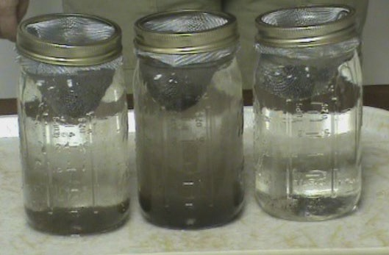

Soil clod test in jars with clods put on screens – The soil clods in the left-hand jar is from a no-till field, the center jar from a conventionally-managed field, and the right-hand jar from a moderately-grazed pasture. All the sites were on the same soil type and were separated by a 0.5 mile or less.

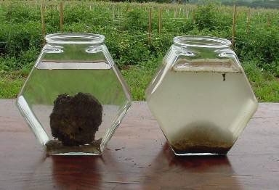
Rodale Institute
Organic System
Non-Organic System

Soil clod test in fishbowls – Soil clods were dropped into fishbowls filled with water. The clod on the left came from soil managed organically while the clod on the right was from a conventionally-managed soil.

What is happening:

- Bubbles will be released as the air in the pore spaces between aggregates is replaced by water. As the clods reach the bottom of the container, the amount of bubbles formed should slow, except in samples that do not have a large amount of stable soil aggregates.
- The bubbles formed after the clod has reached the bottom of the container or after gently shaking are mostly from air trapped within the aggregates. When dry soil gets wet, water rapidly moves into the open space. Air molecules in this open space start to be pushed closer and closer together as the water moves in because the water is denser than the air. As the air molecules get pushed together, pressure starts to build, and eventually blows the aggregate apart. Bubbles are an indicator of that trapped air escaping. If the clod is stabilized by biological glues and waxes, the water moves more slowing into the open space which allows the air molecules time to escape and not get pushed together. In this case, bubbles aren’t formed because the air molecules are grouped together.
- The white scum is an indicator of the presence of glomalin, a biological glue/wax produced by arbuscular mycorrhizal fungi, but this glomalin is not attached to aggregates and forms the scum. Given the right conditions, the glomalin will attach and stabilize the aggregate.

